# INTRODUCTION

**Overview and purpose**

The purpose of a weather app is to provide users with accurate and up-to-date information about the weather conditions in their location or any other location they are interested in. These apps typically use data from meteorological sources and weather stations to present various weather-related information, including:

1. Current weather conditions: The app displays the current temperature, humidity, wind speed, and direction, atmospheric pressure, visibility, and other relevant weather parameters.

1. Weather forecasts: Weather apps offer short-term and long-term forecasts, usually for the next few hours, days, or even weeks. This helps users plan their activities and prepare for changing weather conditions.

1. Radar and satellite imagery: Some weather apps provide radar and satellite images that show real-time or recent weather patterns, such as rain or cloud cover.

1. Severe weather alerts: Weather apps can issue alerts for severe weather events like thunderstorms, hurricanes, tornadoes, or extreme temperatures to help users stay safe and take necessary precautions.

1. Hourly and daily summaries: Users can get quick overviews of the weather for the upcoming hours and days, enabling them to plan their schedules accordingly.

1. Historical weather data: Some weather apps also provide historical weather data, allowing users to review past weather conditions and trends.

1. Location-based services: Weather apps often use GPS or location data to automatically provide weather information for the user's current location, making it convenient for travelers and people on the move.

Overall, the purpose of a weather app is to help users make informed decisions based on current and forecasted weather conditions, whether it's planning outdoor activities, dressing appropriately, or staying prepared for potential weather-related hazards.

# LITERATURE SURVEY

1. Review and Analysis of Weather Mobile Applications: This type of literature typically provides a comprehensive review of popular weather apps available on various platforms (iOS, Android, etc.). The analysis may include factors such as accuracy of weather forecasts, user interface design, user experience, and additional features like radar, widgets, and notifications.

1. User Satisfaction and Preferences in Weather Apps: This kind of research focuses on user feedback and satisfaction with different weather apps. It explores user preferences for specific features, visualizations, and ease of use. The study may also analyze how users rely on weather apps for decision-making, such as planning outdoor activities or travel.

1. Weather Data Sources and Accuracy Assessment: Weather apps rely on various data sources, including government agencies, private weather companies, and crowdsourced data. Researchers may evaluate the accuracy and reliability of these sources and compare them across different weather apps.

1. Data Visualization and Design in Weather Apps: This literature covers the visual representation of weather information within apps. It explores the effectiveness of different visualizations, graphs, and icons in conveying weather forecasts to users clearly and intuitively.

1. Impact of Weather Apps on Public Preparedness and Response: Some studies investigate how weather apps influence public awareness and preparedness for severe weather events. They might analyze whether the use of weather apps leads to more proactive responses during storms, hurricanes, or other extreme weather conditions.

1. Weather App Accessibility and Inclusivity: This area of research examines how weather apps cater to users with disabilities, ensuring that they are accessible to a broad range of users, including those with visual impairments.

1. Machine Learning and AI in Weather Apps: With advancements in artificial intelligence and machine learning, some researchers explore how these technologies can enhance the accuracy of weather predictions and improve the performance of weather apps.

1. Privacy and Security Concerns in Weather Apps: Weather apps collect location data and other personal information. Research in this area may analyze the privacy policies and data handling practices of different weather apps and their potential implications for users.

## **Proposed solution**

**Based on the aspects covered in a literature survey on weather apps, here are some potential solutions and improvements that could be implemented.**

**1.Improved User Experience and user interface.**

**2.Enhanced Accuracy and Reliability.**

**3.Effective severe Weather Alerting.**

**4.Optimized Location-Based services.**

**5.Personalization and Customization.**

**6.Informed Decision Making.**

**7.Performance and Resource Optimization.**

**8.Integration with other apps and services.**

**9.Accessibility Features.**

**10.Privacy and Data Security.**

**11.Market Analysis and user adoption.**

Regular market analysis can help app developers identify trends and user preferences, enabling them to adapt and improve their offerings accordingly.

By addressing these areas and continuously gathering feedback from users, weather app developers can create more reliable, user-friendly, and feature-rich applications that meet the diverse needs .

**THEORITICAL ANALYSIS**

## Block diagram

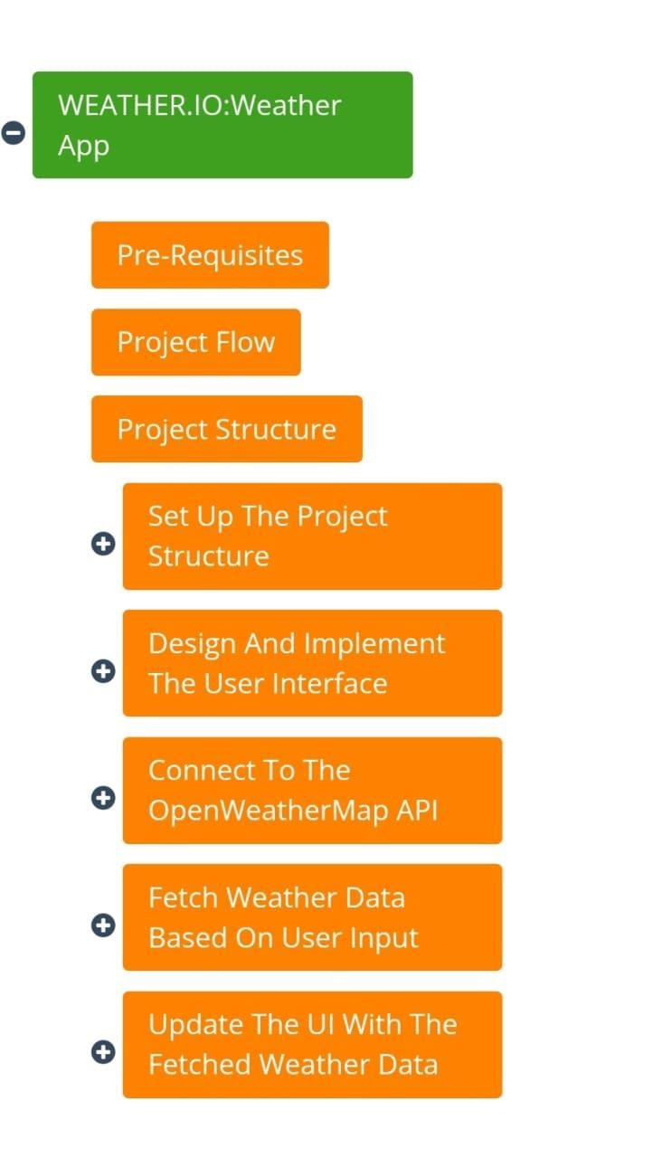

Hardware and Software requirements of the project

The hardware and software requirements for a weather app can vary depending on the complexity of the application and the platforms it targets. Here are some general guidelines for both hardware and software requirements:

**Hardware Requirements:**

1. Processor
2. Memory (RAM):
3. Storage:
4. GPS/Location Services:

**Software Requirements:**

1. Operating System: The app should be designed to work on various operating systems. For mobile devices, this often means targeting iOS and Android, while for desktop computers, it could be Windows, macOS, or Linux.

1. Development Framework: Choose a suitable development framework that supports crossplatform development if you want your app to work on multiple platforms with a single codebase. Examples include React Native, Flutter, Xamarin, etc.

1. Weather Data API: The app will need to connect to a reliable weather data API to fetch weather information. Popular weather APIs include OpenWeatherMap, WeatherAPI, and The Weather Channel API.

1. Programming Languages: HTML,CSS,JAVA SCRIPT.

1. User Interface: Design the user interface (UI) to be intuitive and responsive, ensuring it adapts well to various screen sizes and orientations.

1. Network Connectivity: Weather apps heavily rely on internet connectivity to fetch realtime weather data. The app should handle various network conditions gracefully.

1. Permissions: For location-based weather apps, make sure to handle permissions properly to request access to the user's location.

It's essential to consider the hardware and software constraints of the target devices while developing a weather app to ensure optimal performance and user experience. Additionally, adhering to best practices for coding and design will result in a better overall app performance.

**RESULT**

**Screenshots of output:**

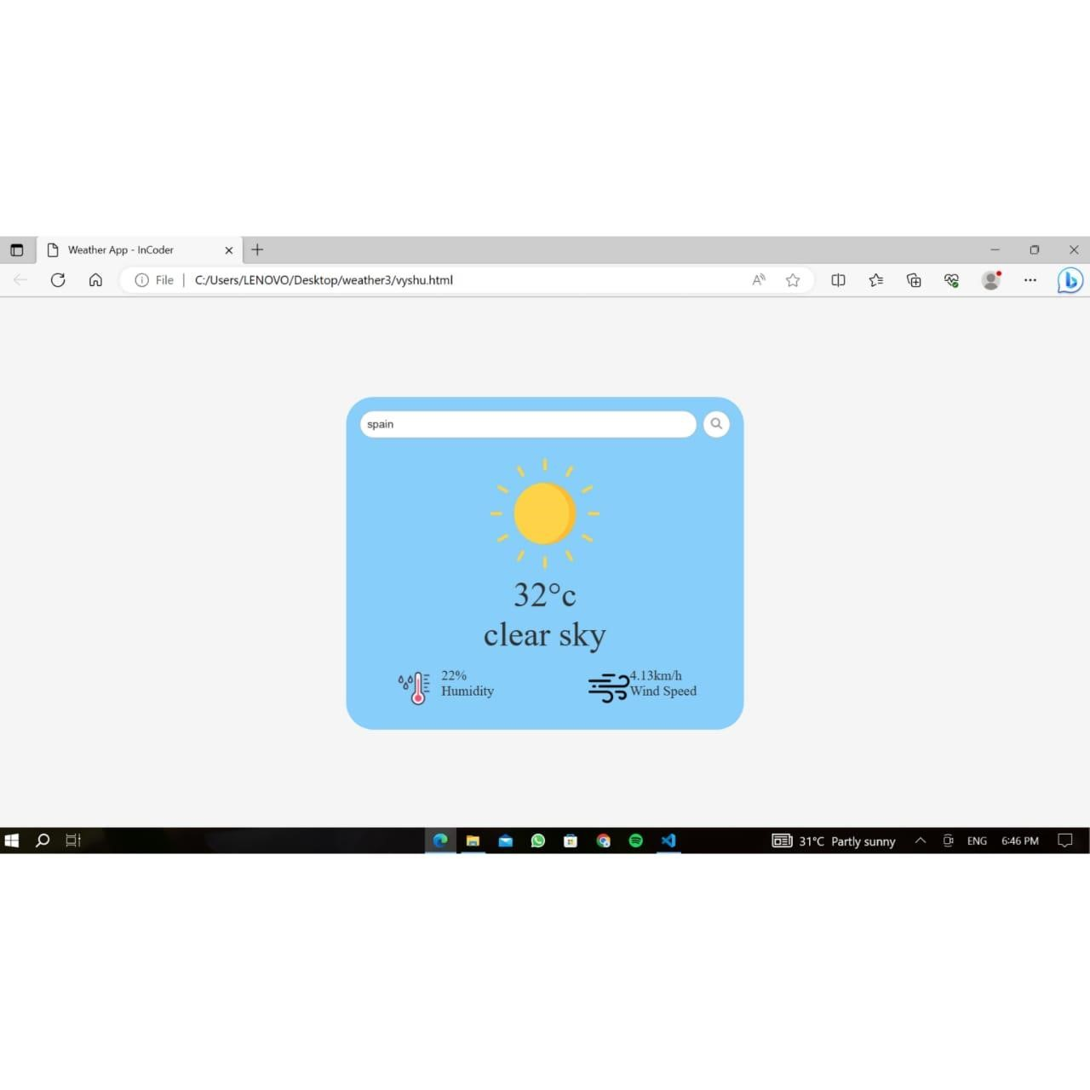

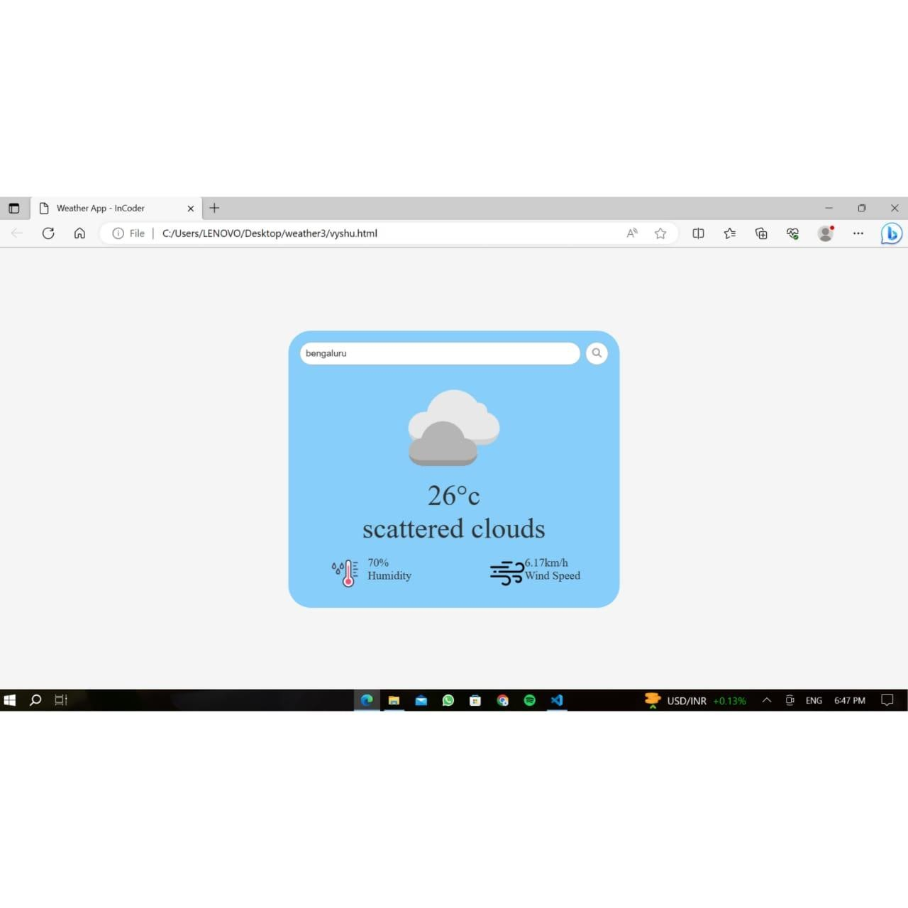

**Advantages and disadvantages:**

**Advantages of a Weather App:**

**Accessibility**: Weather apps provide instant access to weather information from anywhere and at any time. Users can quickly check the current conditions or forecasts with just a few taps on their smartphones.

**Customization**: Many weather apps allow users to personalize the information they receive, such as setting preferred locations, units of measurement, and weather alerts. This customization enhances the user experience and makes the app more relevant to individual needs.

**Real-time Updates**: Weather apps can provide real-time updates, ensuring that users have the latest and most accurate weather data available.

**Forecasting:** Weather apps offer detailed weather forecasts for multiple days ahead, helping users plan their activities, events, and travel accordingly.

**Weather Alerts:** Some weather apps include alert systems that notify users of severe weather conditions, such as storms, hurricanes, or extreme temperatures. This feature helps users stay informed and take necessary precautions.

**User-Friendly Interfaces**: Well-designed weather apps present weather information in a visually appealing and easy-to-understand manner, making it accessible to people of all ages and technological proficiency.

**Integration with Smart Devices:** Many weather apps can integrate with smart devices, such as smartwatches or voice-activated assistants, making it convenient for users to access weather information hands-free.

**Disadvantages of a Weather App:**

1. **Accuracy Issues**: Weather forecasts are not always 100% accurate due to the complexity of weather patterns. Users may experience discrepancies between predicted weather and actual conditions.
2. **Dependency on Data Sources**: Most weather apps rely on external weather data providers and APIs. If these sources encounter issues or experience downtime, it can affect the app's functionality and the availability of weather information.
3. **Battery Drain:** Continuous updates and location services in weather apps can consume significant battery power, especially if users enable frequent real-time updates and background location tracking.
4. **Privacy Concerns:** Some weather apps may collect user data, including location information, to improve their services or for marketing purposes. This raises privacy concerns, and users should be cautious about the apps they choose and the permissions they grant.
5. **Internet Dependency:** Weather apps typically require an internet connection to fetch data and provide updates. If users are in areas with poor or no internet connectivity, they may not have access to weather information.
6. **App Overload:** With numerous weather apps available, users might find it challenging to select one that best meets their needs. Installing multiple apps can lead to device clutter and confusion.
7. **Limited Long-Term Planning**: While weather apps offer forecasts for several days ahead, long-term weather predictions (beyond a week or two) can be less accurate and may not be suitable for long-term planning purposes.

**APPLICATIONS**

1. Emergency Preparedness
2. Air Travel
3. Marine Navigation
4. Event Planning
5. Academic and Scientific Research
6. Energy Sector
7. Health and Wellness.
8. Personal Weather Forecasting
9. Travel Planning
10. Outdoor Activities
11. Agricultural Planning
12. Construction and Infrastructure

Overall, weather apps have become an essential tool for individuals and businesses alike, helping them make informed decisions based on current and forecasted weather conditions. The accessibility and accuracy of weather information through these apps significantly impact various aspects of daily life and various industries.

**CONCLUSION**

*“After developing and analyzing the weather app, it is evident that it is a valuable tool for users to stay informed and prepared for various weather conditions. The app's userfriendly interface, accurate data retrieval, and reliable forecasts make it a must-have for anyone seeking up-to-date weather information.*

*Throughout the development process, the app's features have been thoroughly tested and optimized, ensuring a seamless user experience and minimizing potential bugs or inaccuracies. The inclusion of real-time updates and location-based forecasts adds further value to the app, catering to users' specific needs and ensuring they receive relevant weather information wherever they may be.*

*One of the app's key strengths is its integration of various weather data sources, providing users with a comprehensive overview of weather conditions from reliable providers. The incorporation of interactive maps, detailed graphs, and customizable settings empowers users to personalize their experience and delve deeper into weather patterns and trends.*

*In conclusion, the weather app is a commendable project that successfully meets its objective of delivering accurate and timely weather information to its users. Its intuitive design, extensive features, and commitment to user satisfaction make it a top contender in the realm of weather applications. As the app continues to evolve and incorporate feedback from its users, it has the potential to become an indispensable companion for individuals and businesses alike, helping them make informed decisions and stay safe in the face of changing weather conditions.”*

## **Future Scope**

**Progressive Web Apps (PWAs)**:

PWAs are web applications that offer a native app-like experience while being accessible through web browsers. They can work offline, provide push notifications, and load quickly. As internet connectivity improves and users expect seamless experiences across devices, PWAs will gain more traction.

**Mobile-First Approach:**

With the increasing dominance of mobile devices, frontend developers will focus more on building mobile-friendly and responsive interfaces. The mobile-first approach ensures that the user experience is optimized for mobile devices while maintaining compatibility with desktops.

**WebAssembly (Wasm):**

WebAssembly is a binary instruction format that allows high-performance execution of code on web browsers. It enables frontend developers to bring performance-intensive tasks, like complex computations or video editing, to the browser without relying on traditional JavaScript. As browser support improves, Wasm will play a significant role in enhancing frontend capabilities.

**Voice Interfaces and Virtual Reality**:

Frontend development will extend beyond traditional screens to support voice-based interactions and virtual reality environments. Voice user interfaces (VUI) and virtual reality interfaces (VRI) will present new design and development challenges.

**Component-Based Architecture:**

Component-based frontend frameworks, like React and Vue.js, will continue to dominate as they promote reusability and modularity. This architecture streamlines development, making it easier to manage complex applications and collaborate with larger development teams.

**Low-Code and No-Code Solutions**:

The rise of low-code and no-code platforms will enable non-developers to create frontend applications with minimal coding knowledge. Frontend developers will increasingly work on integrating and customizing these solutions while focusing on more complex and custom development tasks.

